CS5225 Project Progress Report
Members:
- Heney S Panicker HT035943M
- Huang, Donghao HT035913N
- Jerel Yam Wye Kede HT065749W
Project Title:
Autism Digital Assistant

Objective:
The aim of our project is to develop a system to assist people diagnosed with autism in learning environments and real life situations.

Scope:
The system consists of multiple distributed mobile databases stored on Windows Mobile devices that sync with a central database. The central database can then be queried for statistics generation and decision making.

Schema:
We have worked out the schema of the database as follows:
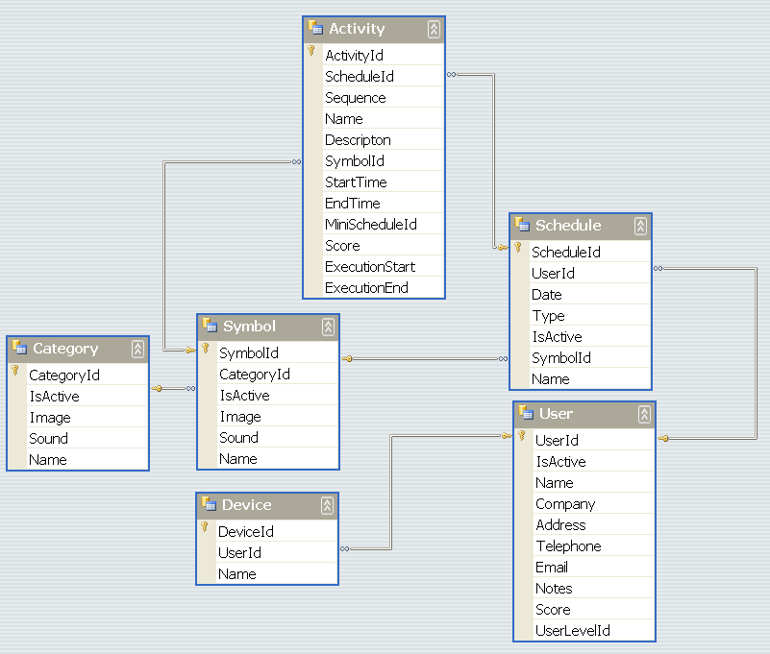

Assignments:
We have assigned the development of the various components as follows:
Application | OS | Description | Assigned To
Control Centre | Windows | Maintain data in Device and User tables | Heney
Symbol Manager | Windows | Maintain data in Category and Symbol tables | Heney
Work System | Windows | Maintain data in Schedule and Activity tables | Jerel
Analyzer | Windows | Analyze data in Schedule and Activity tables | Donghao
Synchronization Pocket PC | Windows Mobile | Synchronize data between SQL compact edition and SQL server 2005 | Donghao
Work System Pocket PC | Windows Mobile | Execute work system and maintain data in Schedule and Activity tables in SQL compact edition | Jerel

